Design DB model for Guvi Zen class

**EER Diagram**

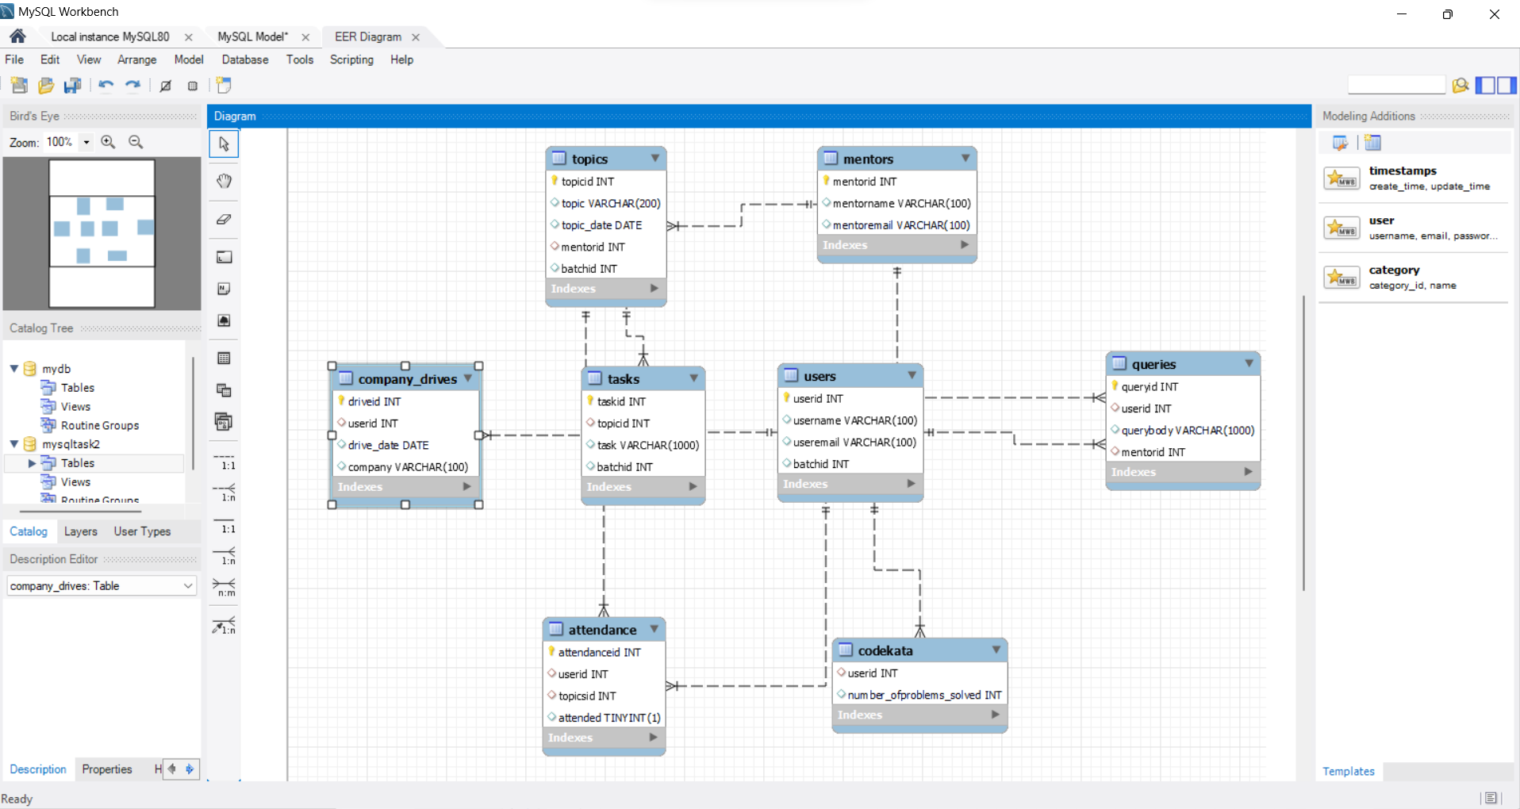

use guvi_zen;

-- Users

CREATE TABLE users (

userid INTEGER AUTO_INCREMENT PRIMARY KEY,

username VARCHAR(100),

useremail VARCHAR(100),

batchid INTEGER

);

INSERT INTO users(username, useremail, batchid) VALUES

("Kavi", "kavi@gmail.com", 28),

("Sam", "sam@gmail.com", 20),

("Chinna", "chinna@gmail.com", 55),

("Savitha", "savitha@gmail.com", 45);

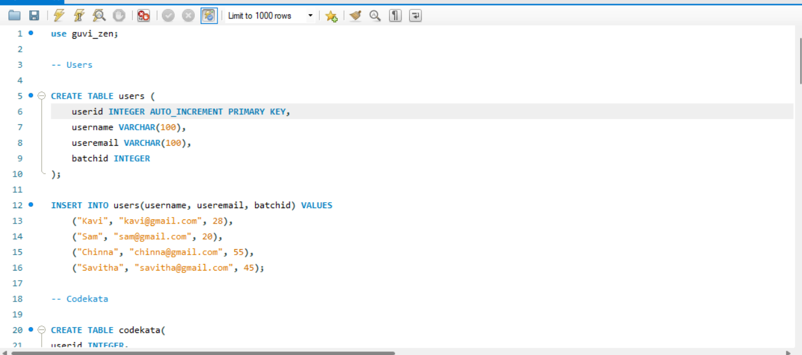

-- Codekata

CREATE TABLE codekata(

userid INTEGER,

number_ofproblems_solved INTEGER,

FOREIGN KEY (userid) REFERENCES users(userid)

);

INSERT INTO codekata(userid, number_of_problems_solved)VALUES

(1,95),

(2,78),

(3,89),

(4,99);

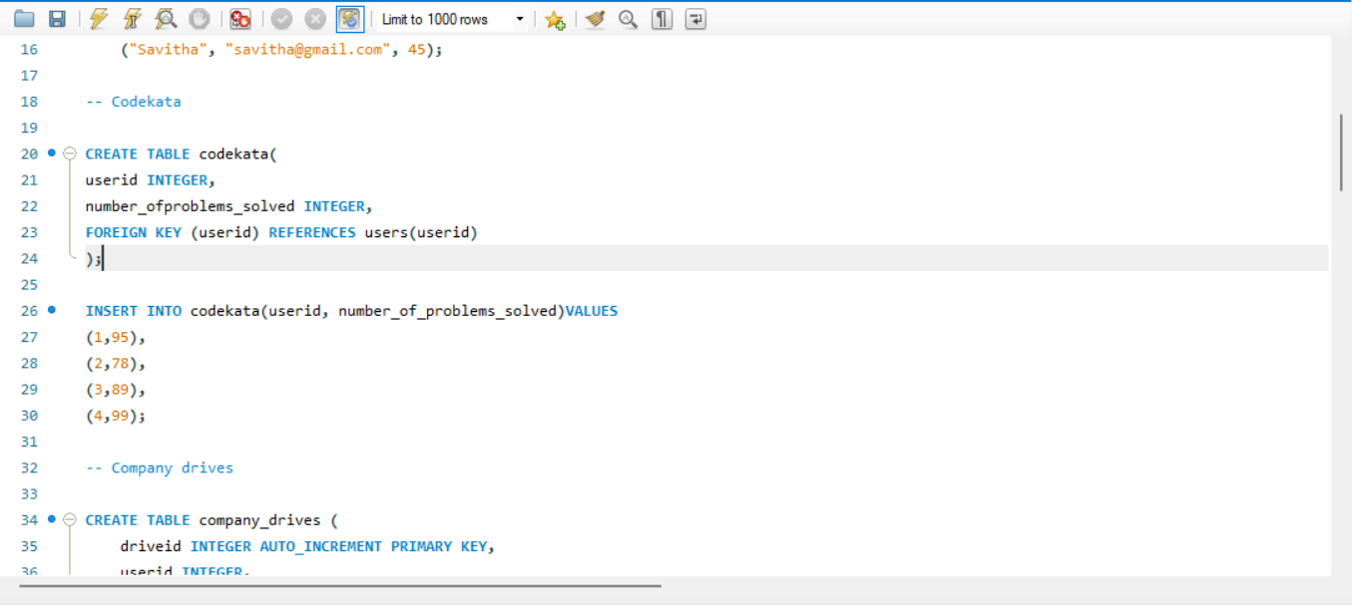

-- Company drives

CREATE TABLE company_drives (

driveid INTEGER AUTO_INCREMENT PRIMARY KEY,

userid INTEGER,

drive_date DATE,

company VARCHAR(100),

FOREIGN KEY (userid) REFERENCES users(userid)

);

INSERT INTO company_drives(userid, drive_date, company) VALUES

(2, "05-05-2024", "Apple"),

(3, "22-07-2024", "Amazon"),

(4, "08-12-2024", "Zomato"),

(1, "05-08-2024", "Flipkart");

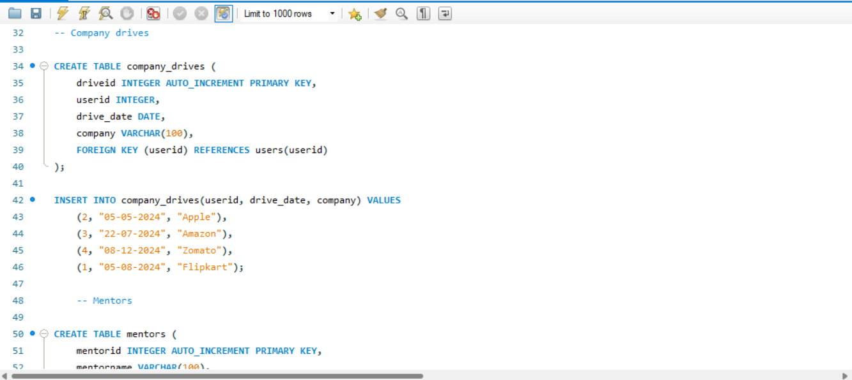

-- Mentors

CREATE TABLE mentors (

mentorid INTEGER AUTO_INCREMENT PRIMARY KEY,

mentorname VARCHAR(100),

mentoremail VARCHAR(100)

);

INSERT INTO mentors(mentorname, mentoremail) VALUES

("Sakthi", "sakthi@gmail.com"),

("Ravi", "ravigmail.com"),

("Muthu", "muthu@gmail.com"),

("Meena", "meena@gmail.com");

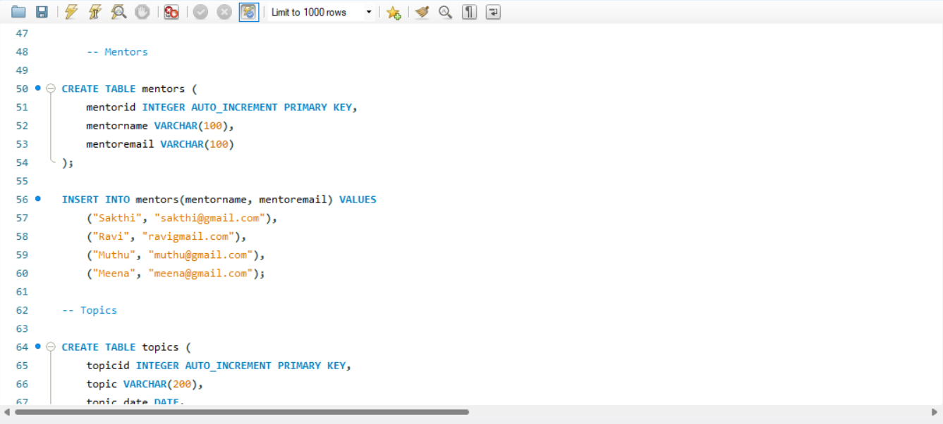

-- Topics

CREATE TABLE topics (

topicid INTEGER AUTO_INCREMENT PRIMARY KEY,

topic VARCHAR(200),

topic_date DATE,

mentorid INTEGER,

batchid INTEGER,

FOREIGN KEY (mentorid) REFERENCES mentors(mentorid)

);

INSERT INTO topics(topic, topic_date, mentorid, batchid) VALUES

("HTML - Basics", "05-06-2024", 1, 50),

("JavaScript - Basics", "11-12-2023", 3, 60),

("React - Basics", "20-01-2024", 4, 51),

("NodeJS - Basics", "29-02-2024", 2, 09);

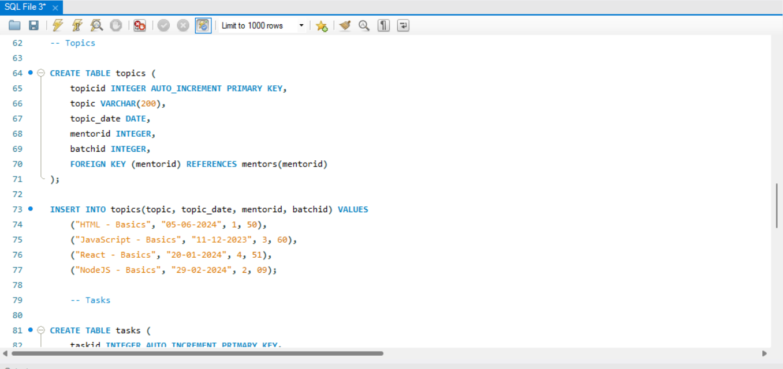

-- Tasks

CREATE TABLE tasks (

taskid INTEGER AUTO_INCREMENT PRIMARY KEY,

topicid INTEGER,

task VARCHAR(1000),

batchid INTEGER,

FOREIGN KEY (topicid) REFERENCES topics(topicid)

);

INSERT INTO tasks(topicid, task, batchid) VALUES

(1, "HTML Task", 10),

(2, "Javascript Task", 09),

(3, "React Task", 08),

(4, "NodeJs Task", 10);

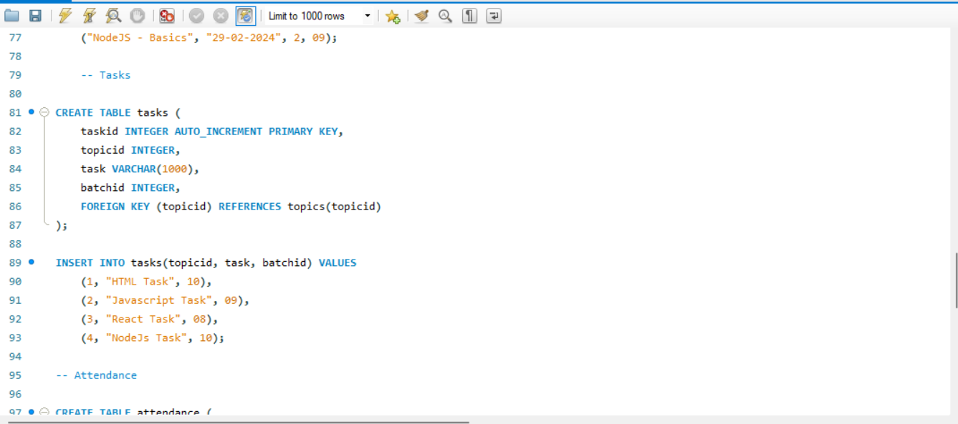

-- Attendance

CREATE TABLE attendance (

attendanceid INTEGER AUTO_INCREMENT PRIMARY KEY,

userid INTEGER,

topicsid INTEGER,

attended BOOLEAN,

FOREIGN KEY (userid) REFERENCES users(userid),

FOREIGN KEY (topicsid) REFERENCES topics(topicid)

);

INSERT INTO attendance(userid, topicsid, attended) VALUES

(2, 3, true),

(4, 1, true),

(1, 2, false),

(3, 4, true);

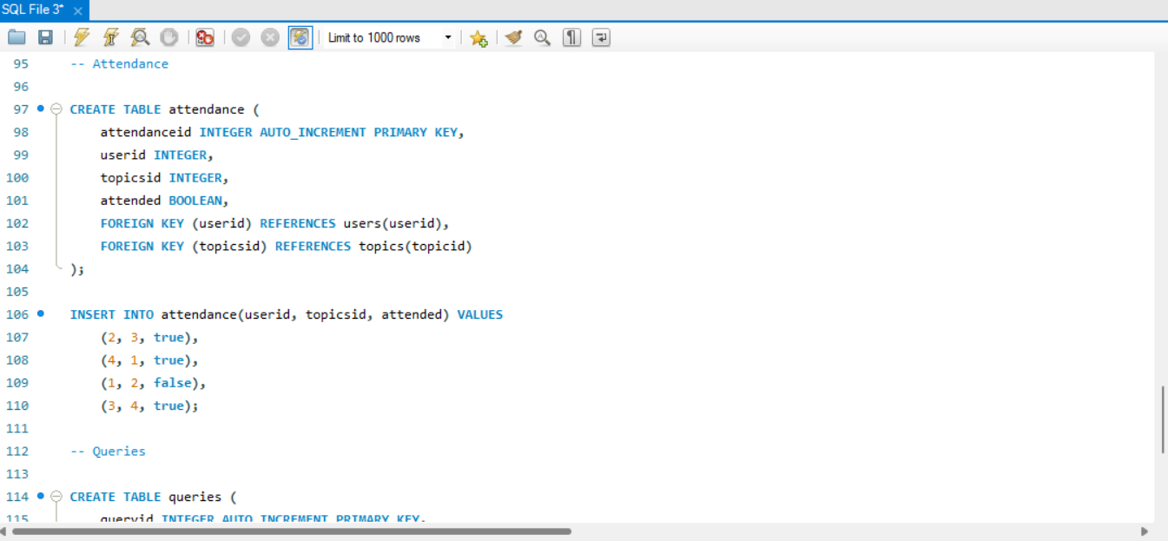

-- Queries

CREATE TABLE queries (

queryid INTEGER AUTO_INCREMENT PRIMARY KEY,

userid INTEGER,

querybody VARCHAR(1000),

mentorid INTEGER,

FOREIGN KEY (userid) REFERENCES users(userid),

FOREIGN KEY (mentorid) REFERENCES mentors(mentorid)

);

INSERT INTO queries(userid, querybody, mentorid) VALUES

(1, "query about HTML", 1),

(3, "query about Javascript",3),

(2, "query about React", 4),

(4, "query about DS", 2);

